BTEC Tech Award in Enterprise

Component 2

Planning for and Pitching an Enterprise Activity

Maison Roberts

P855568

**Contents Page**

|  |  |  |
| --- | --- | --- |
|  |  | Page |
| Section 1 | What is a Micro-Sized Enterprise Activity? | 3 - |
| Section 2 | The Business |  |
| Section 3 | The Market and Market Research |  |
| Section 4 | Marketing Strategy |  |
| Section 5 | Competitors |  |
| Section 6 | Operations and Logistics |  |
| Section 7 | Costs and Price Strategy |  |
| Section 8 | Financial Forecasting |  |
| Section 9 | Risk Assessment and Contingency Plan |  |
| References |  |  |
| Appendix | Market Research Findings  Questionnaires  Tally Charts  Graphs / Charts  Secondary Articles |  |

**Section 1**

**What is a Micro-Sized Enterprise Activity?**

**Definition**

A micro-sized business is a type of small business that employs fewer than 10 people

|  |  |  |
| --- | --- | --- |
| **Idea** | **Positives of Enterprise** | **Negatives of Enterprise** |
| PC repair shop | Helps people in the area needing technical support  Also Draws a lot of business as many people are not tech savvy | At first could be hard to get consumers as they may not trust the business at first |
| Shoe selling business | Easy to start selling with websites such as: Facebook Marketplace, eBay, Stock X and etc | A lot of work goes into the business to send off the shoes so they can be confirmed as authentic and not knock-off’s |
| Tutoring Service -History | Helps teenagers pass their GCSE’s also start up costs are minimal | You need well-rounded knowledge and experience  Travel costs |

**Description of Enterprise PC Repair Shop**

The location of the business could be in a non busy or a busy area but in a busy area you would probably get more customers, Pricing: The pricing would have to be reasonable such as if the job is small like updating things and speeding up the computer it would be a low cost whereas if it was a labour intensive the cost would be much higher suck as changing the CPU or the power supply , who are the customers etc. The advantages of the PC repair shop are that there will be a lot of customers as people are not very tech savvy these days so there will be a lot of business and sometimes it is quite easy fixes which allow you to get a lot of money fast. A disadvantage is people may not trust you and think you might do bad repairs on there product

**Description of Shoe Selling Business**

The location of the business would be anywhere as it would be a remote business but would probably be managed from home as it is very easy to manage because you would have your stock at home the price would be expensive though because demand is very high for shoes it would also be hard to source the items as soon as they drop they sell out so sourcing the products and the ones with demand will be hard to source due to everyone trying to buy that one product

**Description of Tutoring Service**

The location would be remote meaning that I would travel to peoples homes and tutor their kids and managing it would be quite hard as making a schedule and trying to book people in might be a problem as parents have work and it might be hard to setup as you need people to trust you

**My Final Enterprise Choice**

**Enterprise PC Repair Shop**

**Section B**

**The Business**

**BUSINESS NAME – Mayday Electronics**

**The Strapline Because Electronics is complicated enough.**

**Business Overview – Our business repairs and upgrades old or new machines to a newer spec and allows to repair the pc and give it looking brand new to the customer they can also purchase a pc from the shop s**

**What are you going to sell?**

We are going to sell electronic devices such as PC’s Laptops and gaming consoles etc

**Business Aims and Objectives**

**Section 3**

**The Market and Market Research**

**Who are your customers?**

My customers would be people that require technical support or require some sort of electronics help

**How will you sell your products?**

I will sell my products using an online store and also by selling in a physical location customers can purchase the item in store or online and either get it delivered or click and collect

**Your Primary research findings**

**Your Secondary research findings**

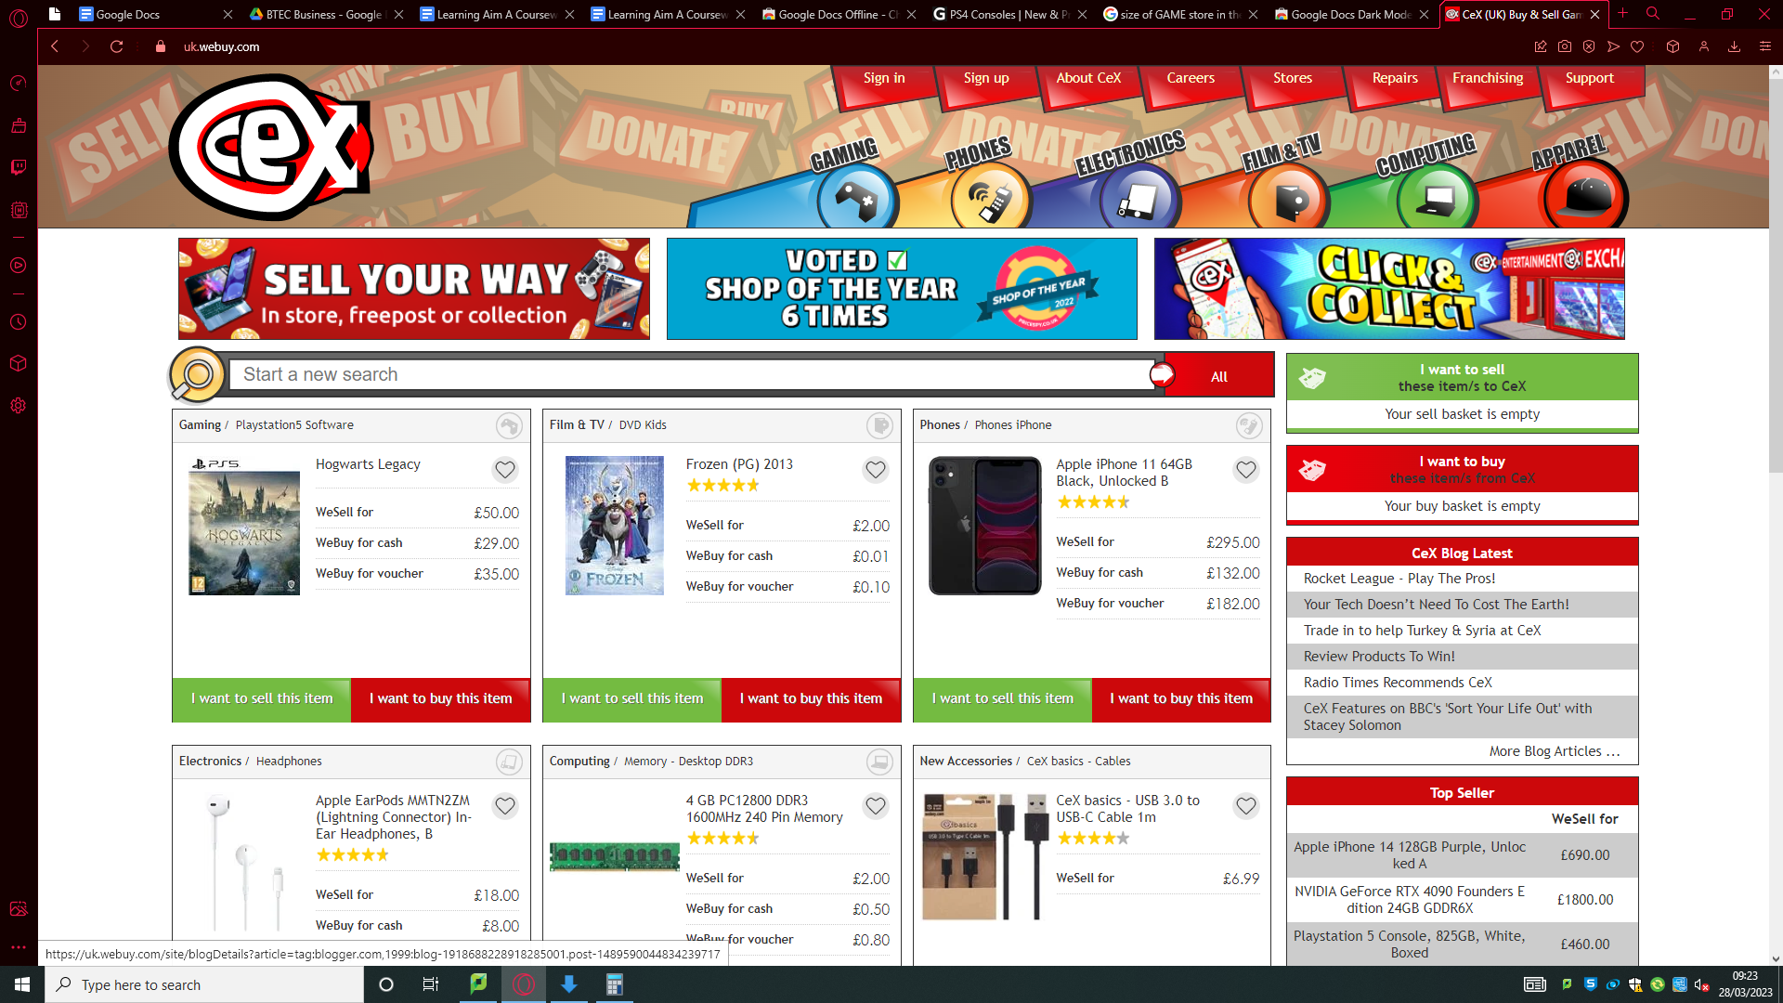

**CEX has a good website as it has sections at the top of the screen such as Gaming, Phones, Electronics ETC and on the front home page has a recommended page for things that are the most popular but cex has one downside with their website which is it is very outdated and needs a new site refresh**

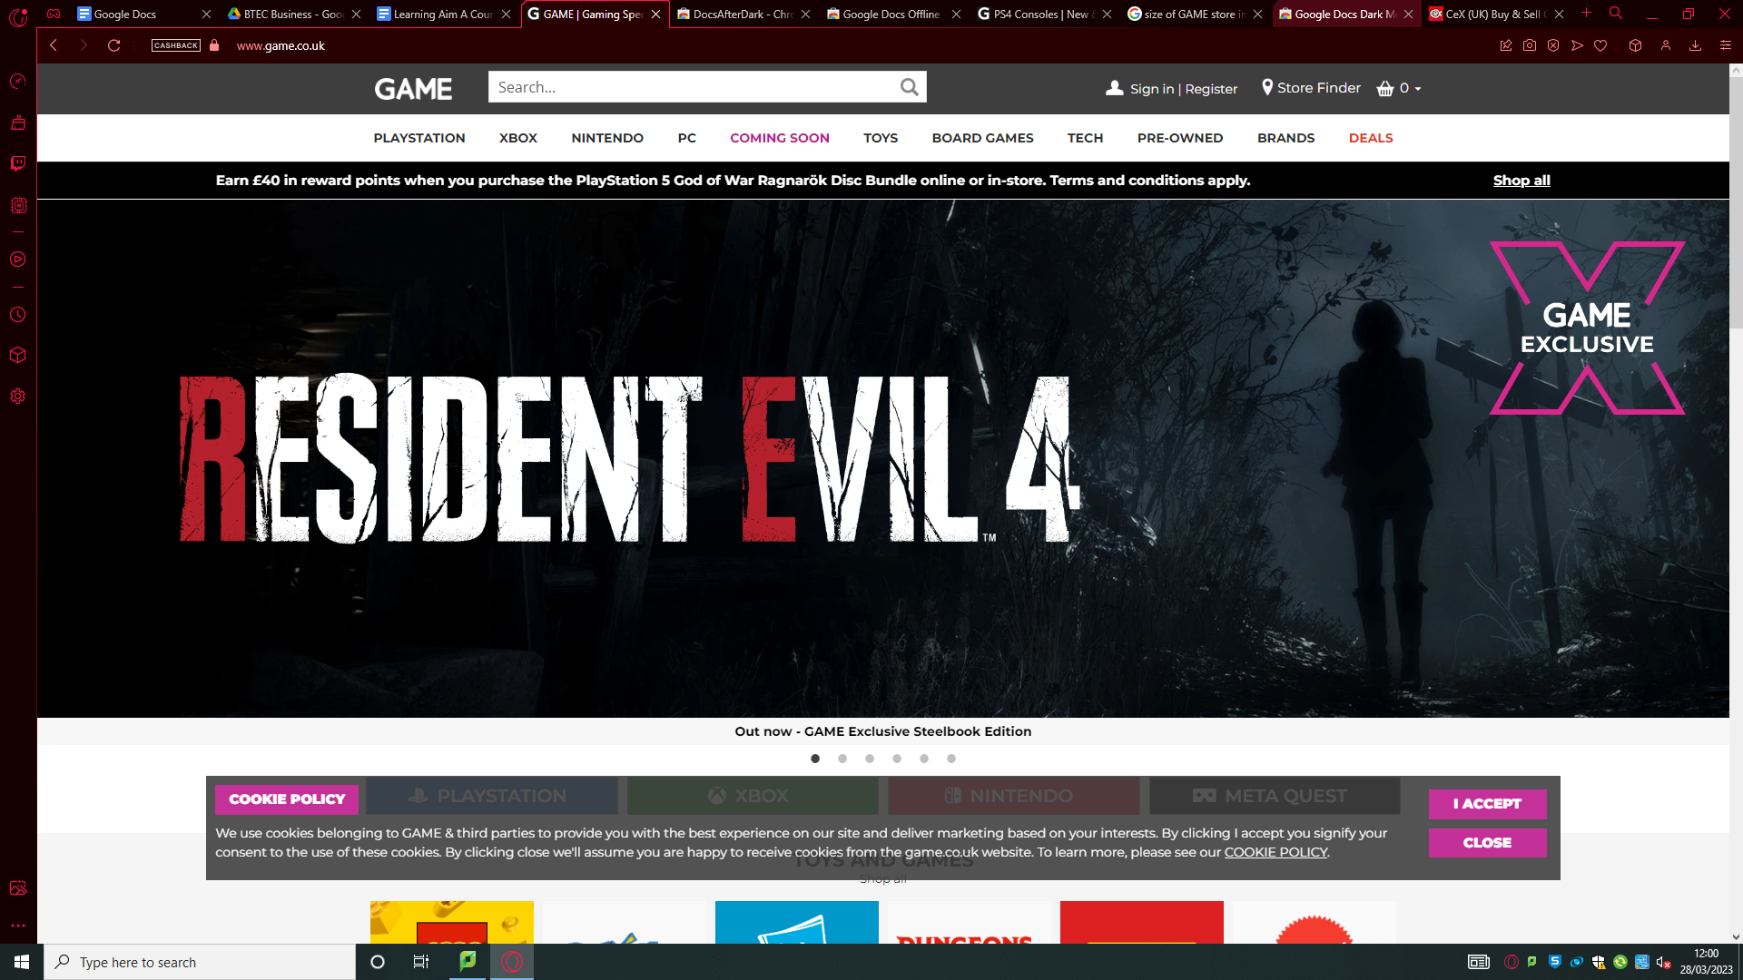

**Game’s website starts off by showing off their “game” exclusive games and then shows their list of consoles they have games for such as Playstation and Meta Quest 2 and has modernised website unlike CEX**

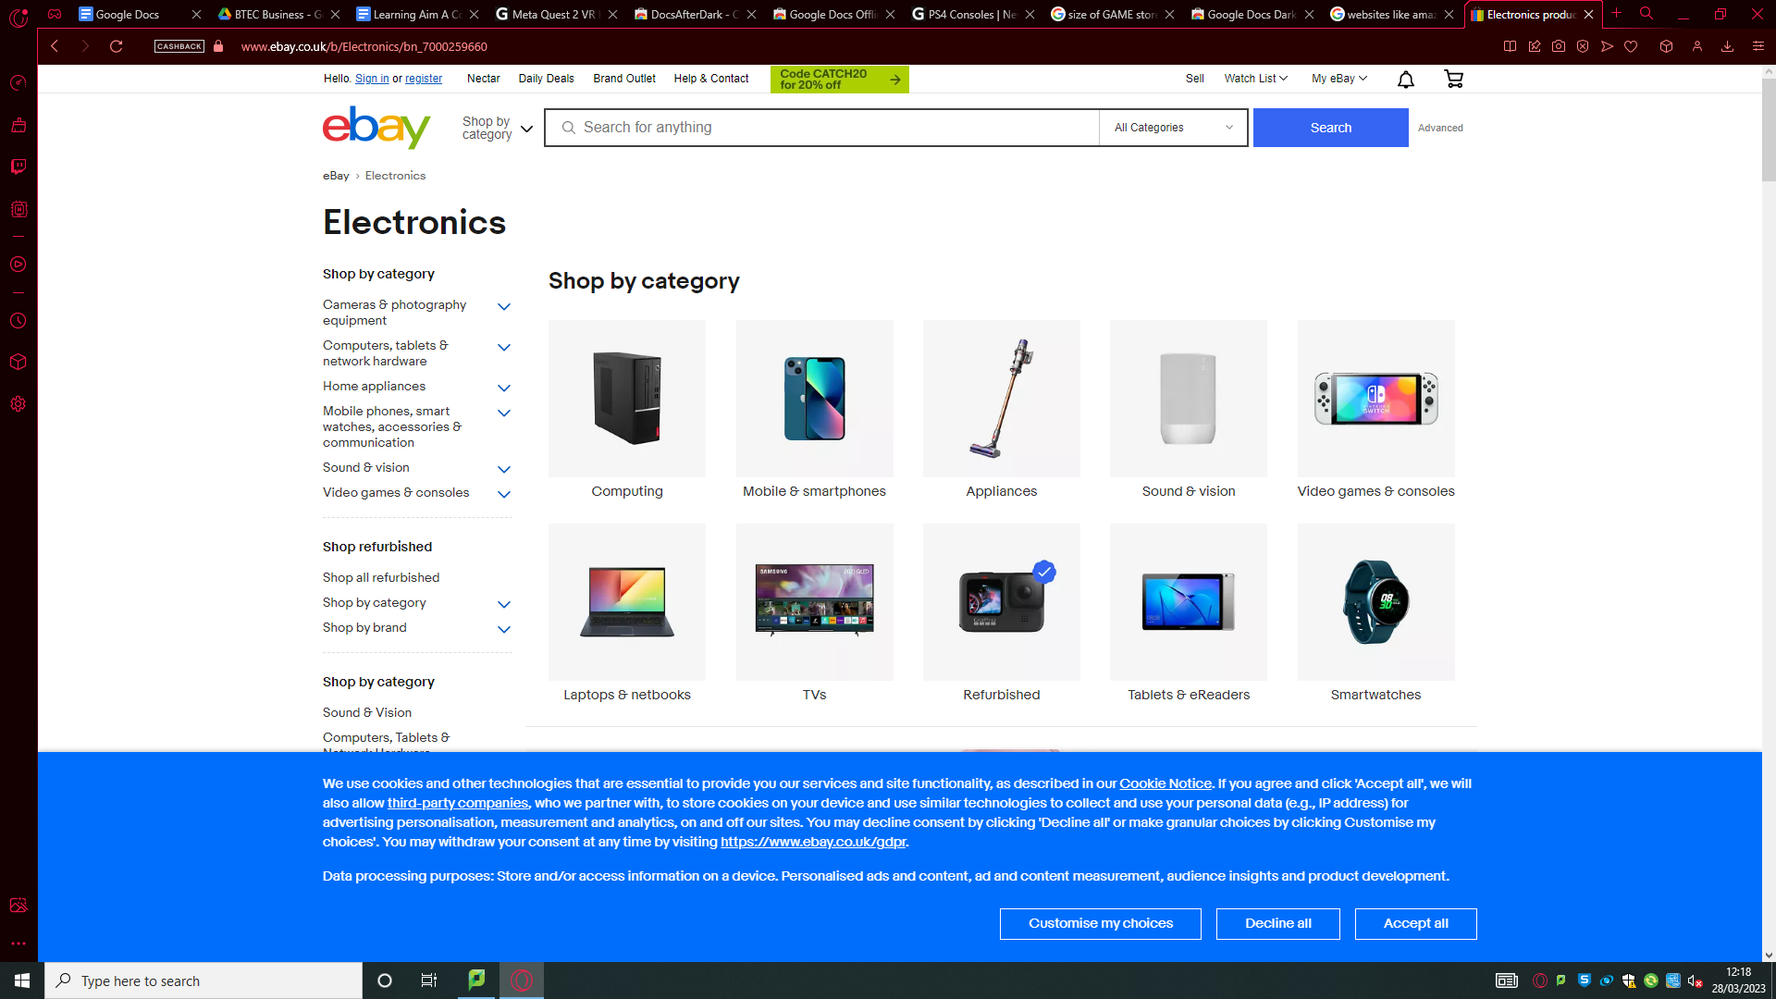

**eBay has a nice category system for listing the products sold on their website which is friendly to the buyer to help find their desired product**

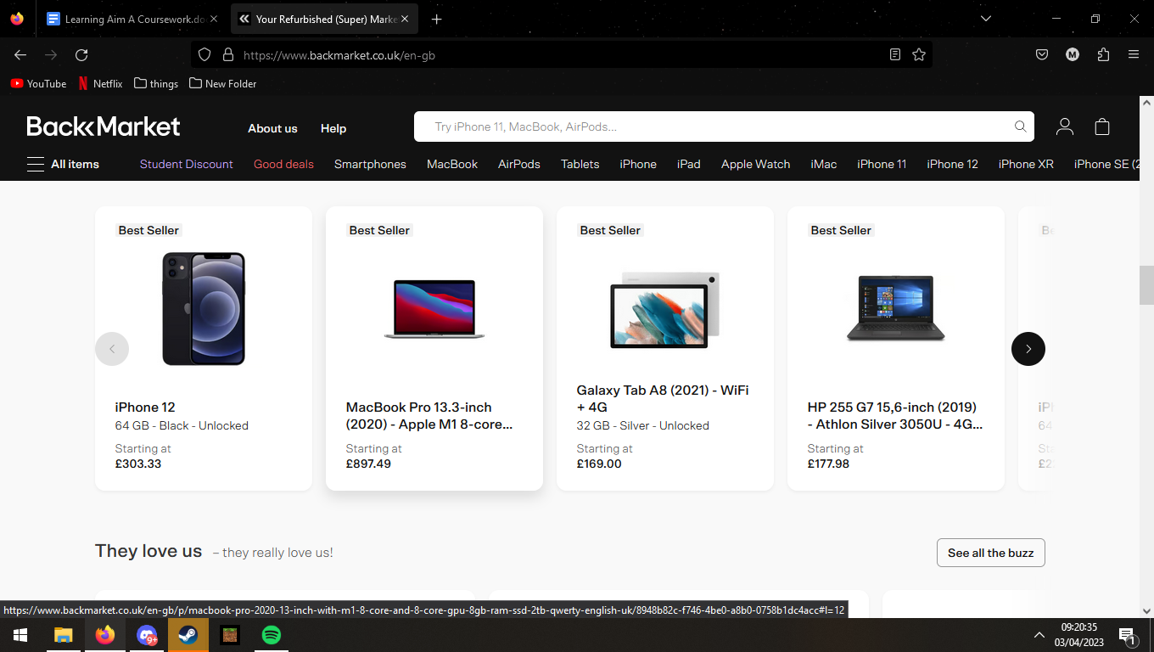

**Backmarket is also a great website to use as it recommends you certain items and even gives university and college students a discount on their website this alsos them to get many customers in as possible**

**Section 4**

**Marketing Strategy**

|  |  |  |
| --- | --- | --- |
| **What are you going to do/** | **Why have you chosen this marketing method?** | **How much will it cost?** |
| Social Media | It is a good way of marketing as it allows you to get the right target audience for your business interests such as if your searching computer repairs | It can depend on what time of year you purchase social media ads or depends on how many average views you want  £1250 |
| Make a colour banner | IT would be a good advertising method as it can be big and catch a passes by eye | It wouldn’t be very costly  Average price: £45 |
| Have a half page advert in the local newspaper | This is also a good method of advertising as lots of people read the newspaper meaning it would get a lot of views but some people may not pay attention to ads in the newspaper | It is not too costly considering the amount of views your advertisement might get skipped by certain people  £125 |
| **Total Cost** | | **£1420** |

**Section 5: Competitors**

|  |  |  |  |  |
| --- | --- | --- | --- | --- |
| **Name, location and size of competitor** | **Product / Service** | **Price** | **Strengths** | **Weaknesses** |
| CEX:  Location: Any town centres etc  Size: More than 380 shops in the UK | Selling Used Games/  Electronics | Depends on price of the electronic example: IPhone 11 64GB is £295 | They have a good customer base and are very popular among people finding electronics | Overpriced and not fair buying price for example IPhone 11 64GB buy price is: £132 Cash £182 Instore Credit and their profit margin is high as they sell it for £295 |
| GAME  Location: Anywhere that is a town or busy  Size: 328 stores as of April 2013 | Sells games and gaming consoles | Average price of new game: £60 | Good customer base and are quite popular and trustworthy and have deals on certain products | Not fair trade in prices such as £87 pounds for PS4 pro cash and £109 instore credit and they sell it for a high profit margin of £199.99 which is a big profit |
| EBAY UK  Location: N/A  Size: Large | Can sell any item at your own desired price instead of a fixed price | Depends on the product but quite expensive | Can sell any product for a desired price | Subject to being scammed by a fake seller |
| Amazon FDA  Location: N/A  Size: Large | Can sell any product listed already on amazon such as your phone or other electronics | Depends on the product but quite expensive | Amazon is one of the biggest online stores in the world which means many people will see you selling your product | It is hard to setup a FDA account to allow you to sell on amazon and could be quite complicated to the uneducated user |
| Argos  Location N/A  Size: Large | Argos sells many electronics such as airpods etc brand new for pretty cheap | Depends on the product but quite expensive | Argos is a well  known store and is trusted by quite a lot of people | Argos sometimes is overpriced and has a overpriced warranty |
| BackMarket  Location: N/A  Size:Large | Can sell used and refurbished electronics | Depends on the product but quite expensive | Backmarket is quite new but is used to sell used phones and refurbished ones for cheap | BackMarket sometimes has stolen phones being sold and might be icloud locked |

**Section 6**

**Operations and Logistics**

**Production**

**I would bulk order multiple screens phones and more products to allow me to fix the broken items**

**Timeline**

I would like to repair/fix the electronics and replace some items a goal for 1 month would be to repair 13 phones for a profit of £502 pounds and sell the game items such as games, phones and electronics to gain even more profit

**Payment Methods and terms**

I would allow giftcards cash, credit card, debit card and would allow a one week refund allowance meaning if the item the person has purchased is faulty they can get it swapped or replaced for no extra charge

**Equipment**

|  |  |  |  |  |
| --- | --- | --- | --- | --- |
|  |  | **If being bought?** | | |
| **Item required** | **Already owned** | **New or second hand?** | **Purchased from** | **Price** |
| Games | 0 | Second Hand | Customers | Varying dependant on the game £500 as a stable starting amount |
| Consoles | 0 | New | Amazon | 50- 500 pounds £1200 to start with |
| Accessories | 0 | New | Amazon | Total of all cases, screen protectors £200 for a decent amount |
| Tools And Parts | 0 | New | Amazon | Total of all parts to replace and repair devices and tools in order to complete jobs £500 |
| Phones | 0 | Second Hand | Customers | Varys Prices during Make and Model of the device such as if it is a new model or a older model of phone such as a IPhone 14 would be worth more than an IPhone 11 |

**Section 7**

**Costs and Price Strategy**

**Start up Costs**

Buying Phones Games and consoles would be well needed start up cost

**Running Costs**

**Running costs would be a warehouse/place of business to store the items**

**Costs and Price per Unit**

|  |  |  |
| --- | --- | --- |
|  | Product/Service Name | Electronic Devices |
| A | Number of units in calculation | 65 |
| B | Cost per Unit | £120 |
| C | Price per unit | £159 |
| D | Profit Margin (£) | £39 |
| E | Profit Margin (%) | 24.53% |

**Breakeven**

**Sources of Finance**

**Bank Loan**

**Profit made from selling products**

**Section 8**

**Financial Forecasting**

**Cashflow Forecast**

|  |  |  |  |  |  |  |
| --- | --- | --- | --- | --- | --- | --- |
|  | **Month 1** | **Month 2** | **Month 3** | **Month 4** | **Month 5** | **Month 6** |
| **Inflows** | | | | | | |
| Sales Revenue | 3975 | 5565 | 7155 | 8745 | 12243 | 17808 |
| Bank Loan | £20,000 | 0 | 0 | 0 | 0 | 0 |
| Grants | £2500 | 0 | 0 | 0 | 0 | 0 |
| **Total Inflows** | **£22500** | **5250** | **7155** | **8745** | **12243** | **17808** |
|  |  |  |  |  |  |  |
| **Outflows** | | | | | | |
| Rent | 1300 | 1300 | 1300 | 1300 | 1300 | 1300 |
| Wages | 1400 | 1400 | 1400 | 1400 | 1400 | 1400 |
| Utilities | 500 | 500 | 500 | 500 | 500 | 500 |
| Raw Mats | 3000 | 4200 | 5400 | 6600 | 9240 | 13440 |
| Website Hosting | 40 | 40 | 40 | 40 | 40 | 40 |
| **Total Outflows** | **6240** | **8,640** | **8,640** | **9,840** | **12,440** | **16,680** |
|  |  |  |  |  |  |  |
| **Opening Balance** | 0 | 16260 | 12,860 | 11,375 | 10,280 | 10,083 |
| **Net Cash Flow** | 16260 | -3400 | -1,485 | -1,095 | -197 | 1,128 |
| **Closing Balance** | 16260 | 12,860 | 11,375 | 10,280 | 10,083 | 11,211 |

**Section 9**

**Risk Assessment and Contingency Plan**

**Risk Assessment**

Stock

It would be unlikely to happen but if this did happen it would cause mass distribution to the workflow

Unexpected Costs

This would cause a minor inconvenience to the business as long as we have money and wouldn’t disrupt the workflow

Financial Resources

This would cause a massive inconvenience to the work as it would allow the business not be able to run and the business would have to run on savings which would cause personal debt

Quality

This would also cause major inconvenience because if the quality was bad we would have many back orders of unsatisfied customers

Competition

This wouldn’t cause much of a issue because we would just use a marketing tactic like 20% to try be better than the competition and maybe even add some loyalty rewards

Lack of customer interest

This would cause a lot of problems as even with the little income from the people coming in this would probably cause the company to go bankrupt

**References**

